**Data3007 reflective essay**

s45748590

guangyu zhang

In the project, I and my group member use a network called DenseNet to classifier the lung x-ray images into three categories, which are the pneumonia, conv19 and normal. DenseNet is a deep convolutional network with direct connection between convolutional layers. The idea is to pass the information in the previous layers directly into later layers so the information in the previous layers is retained. This idea is similar to the ResNet in which the information jumps to the later layers by a direct connection and summation operation. But in DenseNet, the summation operation is replaced by the concatenation and there are more direct connections than the ResNet. The intuition behind this is because we want to pass the information in the previous layers directly to the next layers, while the summation operation can loss some information. The illustration of the model is shown in Figure 1. [1]

In the project, we get a not bad result by using a pre-trained DenseNet network. We use data augmentation to generalize the image by rotation and flipping to prevent the network learning irregularity. Figure 2 shows the result of our model.

However, in the confusion matrix in Figure 2, we can find that there are some possibilities that the classification is wrong. This can be a problem as the cov19 is a quite sensitive topic nowadays. The spreading rate is high and can have a serious impact on the society. In this case, we need a model to that can detect all the cov19 so that the patients can not cause a further spreading of the disease. If the model miss classifies the cov19 patients, even one patient can cause a panic in the hole city block. This is not acceptable. What’s more, if a normal person be detected as cov19 by the model, we will face an ethic issue. Because he will be treated like cov19 patients and live with other patients. This is morally wrong because he will be infected while he could avoid it.

To address this problem, I think we can do it from the perspective of statistics and data science. Firstly, a bagging method or a can be used. By using different models and combine the test results we can increase the accuracy on the test set by decreasing the variance of the model. An example is the random forest. In the situation of lung x-ray analysis, we can use different network models or even the analysis of the doctors, assign a weight to each conclusion, and get the conclusion on a patient.

Secondly, we can use boosting, in which the weight is assigned to the samples for sampling with replacement in the training stage. So that the images that is classified wrong will have more chance to be selected in next training iteration. This can prevent the model from learning irregularity. Figure 3 shows how a boosting algorithm works.

Finally, we can use an attention method to highlight why the x-ray image is classified as cov19,normal or pneumonia. In this way, the network will be interpretable, and can help doctors make decisions with a reliable support. And even the model classifies the patients into wrong category, the doctors can detect it easily as they will know why the model classify a patient as cov19 by looking at the attention regions of the model on that x-ray image.

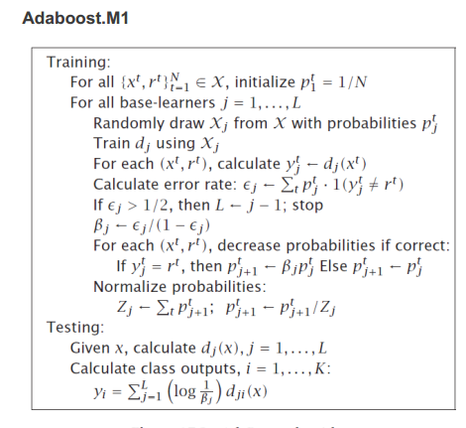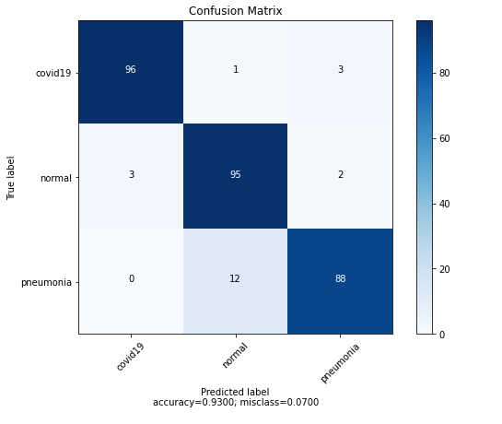

Figure 2

Figure 1 [1]



Figure 3

Reference:

1. Gao Huang. et al. Densely Connected Convolutional Networks. IEEE. 2018.